**Compatibility Analysis of Different Level of Type-n Fuzzy Set**

**Project ID: 14326**

*B.Tech. Final Project Report*

*Submitted for fulfillment of*

*The requirements for the*

*Degree of Bachelor of Technology*

*Under BijuPattnaik University of Technology*

*Submitted By*

**Aman Kumar ROLL NO. 201510698**

**Puja Gupta ROLL NO. 201519681**



*2018- 2019*

*Under the guidance of*

**Dr. Santosh Kumar Das**

**NATIONAL INSTITUTE OF SCIENCE & TECHNOLOGY**

**Palur Hills, Berhampur, Odisha – 761008, India**

# ABSTRACT

In real life, most of the problems are consist of several types of uncertainty and imprecise information. This information cannot handle by the help of traditional methods due to rigid solution. Fuzzy set is a part of soft computing that deals with partial information. Fuzzy logic which is a part of fuzzy set that provides degree of membership function for reducing uncertainty and imprecise information efficiently, in several applications. It is a form of many valued logics in which the truth values of variables may be any real number between 0 and 1. It is employed to handle the concept of partial truth, where the truth value may range between completely true and completely false. The variations of fuzzy logic are type- 1 and type-2. Type-1 fuzzy logic is used to handle uncertainty information with the help of membership function. Type-2 fuzzy logic is used if type-1 fuzzy logic is fails to handle uncertainty information with the help of membership function. Such that we will go further. In this project we will analyze compatibility of different level of type-n fuzzy logic and also deal different types pros and cons of each level.

# ACKNOWLEDGEMENT

We would like to take this opportunity to thank all those individuals whose invaluable contribution in a direct or indirect manner has gone into the making of this project a tremendous learning experience for us.

It is our proud privilege to epitomize our deepest sense of gratitude and indebtedness to our faculty guide, **Dr. Santosh Kumar Das** for his valuable guidance, keen and sustained interest, intuitive ideas and persistent endeavour. His guidance and inspirations enabled us to complete our report work successfully.

We give our sincere thanks to **Dr. Debananda Kanhar & Dr. Sandipan Mallik, Project Coordinators**, for giving us the opportunity and motivating us to complete the project within stipulated period of time and providing a helping environment.

We acknowledge with immense pleasure the sustained interest, encouraging attitude and constant inspiration rendered by **Prof. Sukanta Mohapatra** (Chairman), **Prof. Sangram Mudali**(Director), **Prof. (Dr.) Ajit Kumar Panda** (Dean), **Prof. (Dr.) Shom Prasad Dash** (HOD, School of Computer Science) and **Prof. Geetika Mudali (Placement Director)** N.I.S.T. Their continued drive for better quality in everything that happens at N.I.S.T. and selfless inspiration has always helped us to move ahead.

**Aman Kumar**

**Roll No. IT 201510698**

**Puja Gupta**

**Roll No. CSE201519681**

# TABLE OF CONTENTS

**ABSTRACT i**

**ACKNOWLEDGEMENT ii**

**TABLE OF CONTENTS iii**

**LIST OF FIGURES v**

**CHAPTER 1 1**

**INTRODUCTION 1**

**CHAPTER 2 2**

**LITREATURE RIEVEW 2**

**CHAPTER 3 7**

**PRELIMINARIES 7**

3.1 Crisp Sets 7

3.2 Type-1 Fuzzy Set 8

3.3 Operations on Type-1 Fuzzy Sets 9

3.4 Linguistic Variables 10

3.5 Triangular membership function 11

3.5 Extension principle 11

3.6 Type-2 fuzzy set 12

3.7 Operation on type-2 fuzzy set 15

**CHAPTER 4 16**

**DIFFERENCE BETWEEN TYPE-1 AND TYPE-2 FUZZY SET 16**

**CHAPTER 5 18**

**FUZZY LOGIC APPLICATIONS 18**

5.1 Traffic Signal Control 18

5.2 Fuzzy Logic in Washing Machine 18

5.3. Room Air Cooler 19

5.4. Power Monitoring System 20

5.5 Applications of Fuzzy Logic in Medical Diagnosis 20

5.5.1 Tuberculosis 20

5.5.2 Cancer 20

5.5.3 Diabetes 21

5.5.4 Anesthesia 22

5.6 Type-2 Fuzzy Logic Application 22

5.6.1 Face Recognition 22

5.6.2 Voice Recognition 22

5.6.3 Fingerprint Recognition 23

**CHAPTER 6 24**

**WORK DONE SO FAR 24**

**CHAPTER 7 28**

**RESULT 28**

**CHAPTER 8 30**

**CONCLUSION 30**

**REFERENCES 31**

# LIST OF FIGURES

Fig. 3.1. Interpreting crisp sets as crisp partitions. 7

Fig. 3.2 Fuzzy Set 9

Fig. 3.3 Intersection operation of type-1 fuzzy set 9

Fig. 3.4 Union operation of type-1 fuzzy set 10

Fig. 3.5 Union operation of type-1 fuzzy set 10

Fig. 3.6 Triangular membership function 11

Fig. 3.7 Mapping function from x to y. 11

Fig. 3.8 Type-2 Fuzzy Logic System 14

Fig. 6.1.Fuzzy logic system. 24

Fig. 7.1 Result 28

Fig. 7.2 Output of intersection operation of type-2 fuzzy set 29

Fig. 7.3 Output of intersection operation of type-2 fuzzy set 29

# CHAPTER 1

# INTRODUCTION

Fuzzy Logic was initiated in 1965[1], by Lotfi A. Zadeh, professor for computer science at the University of California in Berkeley. Basically, Fuzzy Logic (FL) is a multivalve logic that allows intermediate values to be defined between conventional evaluations like true/false, yes/no, high/low, etc. Notions like rather tall or very fast can be formulated mathematically and processed by computers, in order to apply a more human-like way of thinking in the programming of computers [2]. Fuzzy systems are an alternative to traditional notions of set membership.

The past few years have witnessed a rapid growth in the number and variety of applications of fuzzy logic (FL). Fuzzy logic poses the ability to mimic the human mind to effectively employ modes of reasoning that are approximate rather than exact. In traditional hard computing, decisions or actions are based on precision, certainty, and vigor. Precision and certainty carry a cost. In soft computing, tolerance and impression are explored in decision making. The exploration of the tolerance for imprecision and uncertainty underlies the remarkable human ability to understand distorted speech, decipher sloppy handwriting, comprehend nuances of natural language, summarize text, and recognize and classify images. With FL, we can specify mapping rules in terms of words rather than numbers. Computing with the words explores imprecision and tolerance. Another basic concept in FL is the fuzzy if–then rule. Although rule-based systems have a long history of use in artificial intelligence, what is missing in such systems is machinery for dealing with fuzzy consequents or fuzzy antecedents. In most applications, an FL solution is a translation of a human solution. Thirdly, FL can model nonlinear functions of arbitrary complexity to a desired degree of accuracy. FL is a convenient way to map an input space to an output space. FL is one of the tools used to model a multi input, multi output system.

# CHAPTER 2

# LITREATURE RIEVEW

Long before the methodology of fuzzy logic had emerged, ancient Greek philosophy conceived the traditional notions of set membership and logic. The efforts of Aristotle and the philosophers who preceded him were largely responsible for the success of mathematics. The postulation of the so-called “Laws of Thought” was the result of their efforts to develop a concise theory of logic, and later mathematics.

Lofty A. Zadeh, a professor for computer science at the University of California in Berkeley, pioneered Fuzzy Logic in 1965 [3] to address the issues of application complexities arising due to nonlinearities, poorly defined dynamics, absence of a priori information, imprecision, uncertainties and vague description of the system. He laid the foundation of fuzzy sets which he defined as ‘a class of objects with a continuum of grades of membership’. He made the use of some of the notions of set membership such as union, intersection, complement, relation, etc. in the same sense as they are used in set membership. At that time, his concept had to face a lot of criticisms, some of which were from his colleagues. A few mathematicians thought that the notions of fuzzy would encourage some sort of imprecise thinking while others believed ‘fuzzification’ is akin of scientific permissiveness. Due to the aforementioned reasons, fuzzy logic developed slowly and its applications came into light after a long time. First industrial applications of fuzzy logic were observed in Europe in 1970s. Later, it became popular because of ease of application in decision making and data analysis. Decision making problems involves many ambiguous and vague objectives and constraints. Therefore, a robust performance evaluation method is a requisite process. In real world problems, these evaluation techniques can handle cases of subjectivity, fuzziness and imprecise information and the implementation of fuzzy sets theory can provide a more precise and optimized value in evaluation systems [4]. Several researchers have emulated the above approach through analytical hierarchy process (AHP), for example in personnel selection and shipping performance evaluation [5], where all the fuzzy sets were aggregated for evaluation.

Researchers have attempted to apply methodology of fuzzy systems in a wide domain. One of these is the optimization of machining with the application of fuzzy system. The implementation of fuzzy system proved to be highly helpful in case of very complex or highly nonlinear processes, in the absence of any simple mathematical model or the need of processing of expert knowledge. Tang, Tseng and Chung [1997] used fuzzy set theory to develop a new pulse discriminator in electric discharge machining (EDM) process. In EDM process, cutting performance indexes such as material removal rate (MRR) and surface roughness have strong relationship with the EDM discharge pulses. Hence it is very important to develop a pulse discriminator in order to classify various discharge pulses in EDM for optimization of machining productivity. The fuzzy pulse discriminator (FPD) consisted of a fuzzier, a knowledge base and an inference engine. In FPD, the EDM discharge pulses were classified based on the linguistic rules attained from the knowledge of experts and expressed mathematically through the fuzzy sets theory. Since the membership functions of FPD have a great influence on its classification performance, the relevant membership functions have been synthesized automatically with the application of a machine learning method. This method was based on a simulated annealing algorithm which is a heuristic search technique. This approach can classify EDM discharge pulses correctly and instantly under varying cutting conditions. The work was to develop a robust, versatile and high speed EDM technique. This was achieved by optimizing the machining precision and accuracy with the application fuzzy logic analysis incorporation with the Taguchi dynamic method. They employed a fuzzy logic system to study the association of machining precision with machining accuracy. The fuzzy system is composed of a fuzzier, an inference system, a data base, a rule base and defuzzifier, and further used ANOVA to determine the process parameters that significantly affect the multiple performance characteristics (MPCs) and a confirmatory test of the calculated optimal.

Fuzzy logic coupled with artificial neural networks (ANN) has been utilized in a wide range of domains (ANFIS) model for predicting the average surface roughness and white layer thickness (WLT) in the wire-EDM process. ANFIS model is made by the fusion of fuzzy inference system (FIS) and artificial neural network (ANN) approaches as it uses the FIS modeling function and the ANN learning ability. A hybrid learning algorithm, which merges the gradient method with the least squares method to optimize the process parameters, forms the basis of this model. The machining parameters which were input to the model are pulse duration, open circuit voltage, dielectric flushing pressure and wire feed rate. Fuzzy if-then rules of Surgeon type make the rule base ofANFIS. To predict the desired performance parameters, the authors performed normalization of measured performance parameters using standard min-max normalization methodology, feature reduction using principal component analysis (PCA)and ANFIS tests using computer simulation. It was concluded that the proposed approach can be of great use for optimization of surface roughness and WLT in the wire-EDM process.

Kuo and Cohen [1998] proposed a self-organizing and self-adjusting fuzzy model (SOSAFM) which was based on the integration of fuzzy logic and ANN. They presented an online estimation system which can be applied in the manufacturing control area. In this approach, Kohonen’s feature mapping is employed to divide the inputs and outputs to the system and error back propagation (EBP)-type learning algorithm is used to improve training parameters of ANNs. Evaluation of the proposed methods was done by conducting some physical experiments for manufacturing process control. SOSAFM is found to be better than the multiple regression and artificial neural network both with respect to speed and accuracy for the purpose of multi-sensor integration. For predicting the surface roughness of the work piece after the completion of end milling process, an adaptive network based fuzzy inference system (ANFIS). Considering that spindle speed, feed rate and depth of cut are the three parameters of milling process that have a major influence on the surface roughness, these performance parameters were analyzed. A comparison between the triangular and trapezoidal membership functions was made during the training process of ANFIS to examine the accuracy in predicting the surface roughness by these two membership functions. Results showed very satisfactory predicting accuracy when either of the membership functions is used while the prediction accuracy of ANFIS has reached as high as 96%when a triangular membership function is employed [6].

Machining data play a vital role in the efficient utilization of machine tools and thus significantly influences the overall manufacturing costs. Machining Data Handbook [7], published by Met cut Research Associates, is a vast information source that compiles machining data for different combinations of tool-work. Baradie [1997] suggested the need and importance of computerization of the Machining Data Handbook which would provide an easy access to an immense collection of machining data and lead to the integrated automation of the manufacturing process. He demonstrated the implementation of a fuzzy logic model for metal cutting operation to develop a computerized machining database system that could be a great aid to the process planner for establishment of the strategy for selecting machining data for a specific machining process. In machine ability data hand book, one may find different tool materials possible for each work material and hardness. So it proves to be an ample way for selecting cutting parameters in machining processes. But in some cases, uncertainty may occur if more than one choice is applicable for a particular cutting condition.

To overcome this problem, Hashmi, Baradie and Ryan applied fuzzy logic principles for selection process. The material hardness and the cutting speed are considered the fuzzy input and output variables respectively. The fuzzy if-else rules are synthesized based on the information extracted from the used machine tool. The triangular shaped membership functions are employed for both input and output. He compared the cutting speed values predicted using the fuzzy logic model with the speed values recommended by the Mach inability Data Handbook and the results showed a good correlation between two speed values.

Fuzzy decision support system (FDSS) based on the compositional rule of inference (CRI). CRI preserves a maximum amount of information contained in the rules and the observations. It is based on the inference method of approximate reasoning applied for handling imprecise information. They attempted the application of FDSS to the choice and modification of cutting parameters considering metal cutting processes to be stochastic, nonlinear and ill-defined. The reasonable results showed that the proposed method would be appropriate for such kinds of decision problems [8]. The parameter selection of the EDM is an obscure problem which is difficult to model as it depends on heuristics and is based on experts’ experiences. Fuzzy set theory can play a major role in such problems and fuzzy logic can be employed to emulate the performance of the expert and provide decision making abilities in the presence of certain degree of vagueness. Following this approach, Yilmaz, Eyercioglu and Gindy (2006) developed a user-friendly intelligent system based on fuzzy logic to make the selection of EDM parameters easy and accurate. A compact selection method is used based on expert rules which are evaluated by the fuzzy set theory. A fuzzy model has been developed which uses fuzzy expert rules, triangular membership functions for fuzzification and centroid area method for defuzzifcation processes. A system has been implemented based on proposed model which helps an unskilled user to select important parameters according to the specific operation [9].

# CHAPTER 3

# PRELIMINARIES

## 3.1 Crisp Sets

Set A in a universe of discourse X (which provides the set of allowable values for a variable) can be defined by listing all of its members or by identifying the elements X ⊂ A. One way to do the latter is to specify a condition or conditions for which x ⊂ A thus, A can be defined as A = {x|x meets some condition(s)}. Alternatively, one can introduce a zero-one membership function (MEMBERSHIP FUNCTION) (also called characteristic function, discrimination function, or indicator function) for A,

DenotedµA(x), such that

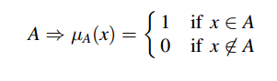

Set A (which can also be treated as a subset of X) is mathematically equivalent to its membership function µA(x), in the sense that knowing µA(x)), is the same as knowing an itself. In order to distinguish between a set and a fuzzy set, the former will be referred to as a “crisp set.”

Example: -Suppose that the domain of x is partitioned into five regions, and one knows exactly where the dividing line is between each region,

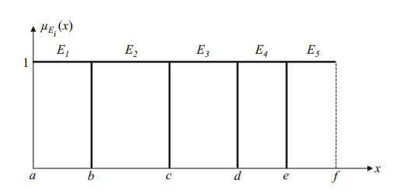

**Fig. 3.1. Interpreting crisp sets as crisp partitions.**

So one is in the situation that is depicted in, where no uncertainty exists about x =b, c, d, e. Each of the intervals [a; b], (b, c], (c, d], (d, e], (e, f] is a crisp partition, i.e. x is either in it (with membership value of 1) or not initiate (with membership value of 0), and x cannot simultaneously be in more than one of these intervals. Each interval is associated with a crisp set that is described by a linguistic term, E1; or E2; or . . .; or E5, such as a level of temperature or pressure, and there is always a sharp jump from one set to another at x = b, c, d, e. as mentioned in connection with Fig. 3.1a, this crisp model serves us well in many situations, but it does not allow any uncertainty about x =b, c, d, e. A fuzzy set will allow for this, as shall be seen.

## 3.2 Type-1 Fuzzy Set

A type-1 fuzzy set A is (Aisbett et al. 2010) a set function of Universe X (sometimes denoted DA) into [0, 1] possibly constrained to belong to a family such as continuous functions, i.e.µA(x) 🡪[0, 1]. The membership function of A is denoted µA(x) and is called a type-1membership function, i.e.

A={(x, µA(x)) |x∈X}

In which 0≤ µA(x) ≤1. A can also be expressed in fuzzy set notation4 for continuous universes X, as

A=∫µA(x) /x

x ∈X

Where∫ denotes union over all x ∈X, or for discrete universes Xd, as

A=∑ µA(x)/x

x∈Xd,

Where ∑ denotes union over all x ∈Xd. The slash is associates the elements in X with their membership grades, where µA(x) ≥0. The value of µA(x) is called the degree of membership, or membership grade, of x in A. If µA(x) =1 or µA(x) = 0 for all x∈X, then the fuzzy set A reduces to a crisp set.

µA(x) is also said to provide a measure of the degree of similarity of an element in X to the fuzzy set. Note that A can also be treated as a subset of X. Unlike a crispest, that can be described in different ways); a fuzzy set can only be described by its membership function.

## 3.3 Operations on Type-1 Fuzzy Sets

We can introduce basic operations on fuzzy sets. Similar to the operations on crisp sets we also want to intersect, unify and negate fuzzy sets. In his very first paper about fuzzy sets [1], L. A. Zadeh suggested the minimum operator for the intersection and the maximum operator for the union of two fuzzy sets. It can be shown that these operators coincide with the crisp unification and intersection if we only consider the membership degrees 0 and 1.

In order to clarify this, we give a few examples. Let *A* be a fuzzy interval *between* 5 *and* 8 and *B* be a fuzzy number *about* 4. The corresponding figures are shown below.  
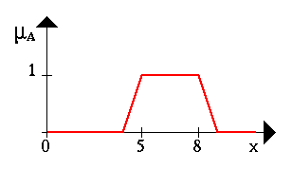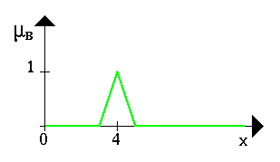

**Fig. 3.2 Fuzzy Set**

The following figure shows the fuzzy set *between* 5 *and* 8 and about 4 (notice the blue line).

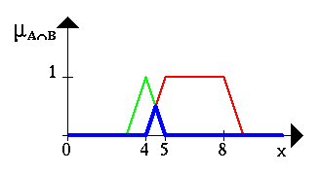

**Fig. 3.3 Intersection operation of type-1 fuzzy set**

The Fuzzy set *between* 5 *and* 8 or*about* 4 is shown in the next figure (again, it is the blue line).

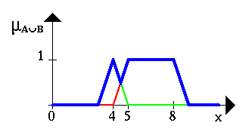

**Fig. 3.4 Union operation of type-1 fuzzy set**

This figure gives an example for a negation. The blue line is the negation of the fuzzy set *A.*

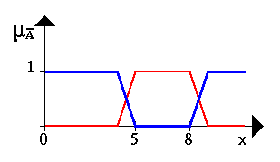

**Fig. 3.5 Negation operation of type-1 fuzzy set**

## 3.4 Linguistic Variables

If a variable can take words in natural languages as its values, it is called a linguistic variable, where the words are characterized by fuzzy sets defined in the universe of discourse in which the variable is defined [Wang 1997]. Each linguistic variable [Klir and Yuan 1995; Zadeh 1973, 1975] is fully characterized by a quintuple (v, T, X, g, m) in which v is the name of the variable, T is the set of linguistic termsof v that refer to a base variable whose values range over the universal set X, g is a syntactic rule for generating linguistic terms, and m is a semantic rule that assigns each linguistic term t∈T its meaning, m(t), which is a fuzzy set on X, that is, m:T🡪F(X), where F(X) denotes the set of fuzzy sets of X, one fuzzy set for each t∈T. It is common to refer to v as the linguistic variable.

## 3.5 Triangular membership function

Triangular function: defined by a lower limit a, an upper limit b, and a value m, where

 a <m<b.

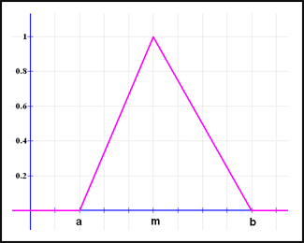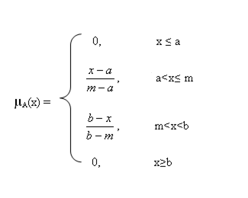

**Fig. 3.6 Triangular membership fu itnction**

## 3.5 Extension principle

Extension principle is used as a mathematical instrument that takes crisp mathematical notions and procedures, extend them to the fuzzy realm, resulting in computable fuzzy sets by fuzzifying the parameters of a function.

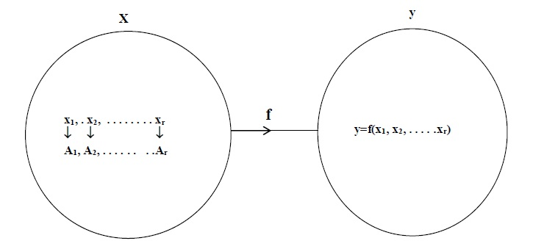

**Fig. 3.7 Mapping function from x to y.**

Mapping f: X🡪Y

where y=f(x1, x2, x3, . . . . . xr)

Let A1, A2, …, An be FS’s in X1, X2, …, Xn, respectively.

X = x1 * x2 *x3…………*xnandf: X 🡪Y, y = f(x1, x2, xn), then extension principle allows us to map FS’s in X to Y as follows:

$\underline{B}$ = f (A) where $\underline{B}$ is the fuzzy set in Y:

$\underline{B}$ = {(y, µB(y)) | y=f ( x1, x2, x3,……….,xn) ∈ X}

(min [(µĀ1(x), µĀ2(x),.., µĀn(x)]),if $f^{-1}$ (y) ≠0

$µ_{\underline{B}}$ (y) =

0 , otherwise

## 

## 3.6 Type-2 fuzzy set

Type-2 fuzzy sets and systems generalize standard type-1 fuzzy sets and systems so that more uncertainty can be handled. From the very beginning of fuzzy sets, criticism was made about the fact that the membership function of a type-1 fuzzy set has no uncertainty associated with it, something that seems to contradict the word fuzzy, since that word has the connotation of lots of uncertainty. So, what does one do when there is uncertainty about the value of the membership function. The answer to this question was provided in 1975 by the inventor of fuzzy sets, Prof. Lotfi A. Zadeh [1] when he proposed more sophisticated kinds of fuzzy sets, the first of which he called a type-2 fuzzy set. A type-2 fuzzy set lets us incorporate uncertainty about the membership function into fuzzy set theory, and is a way to address the above criticism of type-1 fuzzy sets head-on. And, if there is no uncertainty, then a type-2 fuzzy set reduces to a type-1 fuzzy set, which is analogous to probability reducing to determinism when unpredictability vanishes.

There are three sources of uncertainties in type-1FLSs:

1. The meanings of the words that is used in the antecedents and consequents of rules can be uncertain (words mean different things to different people).
2. Measurements that activate a type-1 FLS may be noisy and therefore uncertain.
3. The data that are used to tune the parameters of a type-1 FLS may also be noisy.

All of these uncertainties translate into uncertainties about fuzzy set membership functions. Type-1 fuzzy sets are not able to directly model such uncertainties because their membership functions are totally crisp. On the other hand, type-2 fuzzy sets are able to model such uncertainties because their membership functions are themselves fuzzy. Membership functions of type-1 fuzzy sets are two-dimensional, whereas membership functions of type-2 fuzzy sets are three-dimensional. It is the new third-dimension oftype-2 fuzzy sets that provide additional degrees of freedom that make it possible to directly model uncertainties.

A type-2 fuzzy set, denoted, is characterized by a type-2 membership function

Ā ={(x, $µ_{\underline{A}}$ (x)) | ∀x ∈ X}

Where $µ_{\underline{A}}$ (x)={ui, µui

where x ∈Ꭓ and i.e., u ∈ jx⊆ [0, 1]

In which. 0 ≤ µÃ(x) ≤ 1

The structure of the Type-2 fuzzy rules is the same as for the Type-1 case because the distinction betweenType-2 and Type-1 is associated with the nature of the  
membership function Hence, the only difference is that now some or all the fuzzy sets involved in the rules are of Type-2. In a Type-1 fuzzy system, where the output sets are Type 1 fuzzy sets, we perform defuzzification in order to get a number, which is in some sense a crisp (type-0) representative of the combined output sets. In the Type-2 case, the output sets are of Type-2, so we have to use extended versions of Type-1 defuzzification methods. The structure ofType-2 fuzzy logic system is shown in fig 3.8. A Type-2 membership grade can be any sub-set in [0, 1] the primary membership and corresponding to each primary membership, there is a secondary membership (which can also be in [0, 1]) that defines the possibilities for the primary membership. A Type-2FLS is characterized by IF-THEN rules, where their antecedent or consequent sets are now of Type 2. Type-2 FLSs, can be used when the circumstances are too unknown to determine exact membership grade such as when the training data is affected by noise.

Components of type -2 fuzzy logic system

1. Fuzzifier: Convert the crisp set into fuzzy set
2. Rules: The structure of rules in a Type-1 FLS and a Type-2 FLS is the same, but in the latter the antecedents and the consequents is represented byType-2 fuzzy sets.
3. Type reducer: The type-reducer generates a Type-1 fuzzy set output, which is then converted in a numeric output through running the defuzzifier. This Type-1 fuzzy set is also an interval set, for the case of our FLS we used center of sets type reduction
4. Defuzzifier: From the type- reducer, we obtain an interval set Y, so the defuzzified output can be obtained

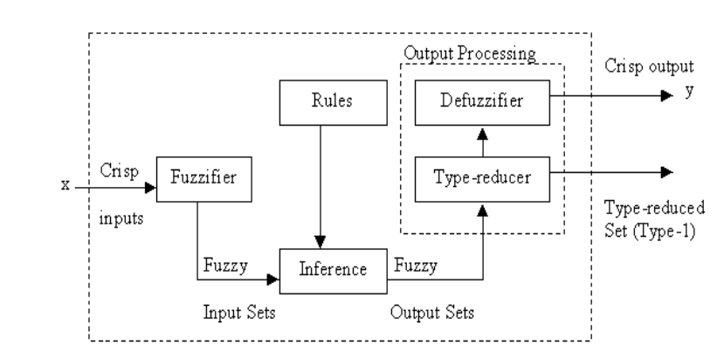

**Fig. 3.8 Type-2 Fuzzy Logic System**

Type-2 sets can be used to convey the uncertainties in membership functions of  
type-1 fuzzy sets, due to the dependence of the membership functions on available  
linguistic and numerical information. Linguistic information (e.g. rules from experts), in general, does not give any information about the shapes of the membership functions. When membership functions are determined or tuned based on numerical data, the uncertainty in the numerical data, e.g., noise, translates into uncertainty in the membership functions. In all such cases, any available information about the linguistic/numerical uncertainty can be incorporated in the type-2 framework. However, even with all of the advantages that fuzzy type-2 systems have, the literature on the applications of type-2 sets is scarce. We think that more applications of type-2 fuzzy systems will come in the near future as the area matures and the theoretical results become more understandable for the general public in the fuzzy arena.

In industry, type-2 fuzzy logic and neural networks was used in the control of non-linear dynamic plants (Melin and Castillo, 2004) also in the field of mobile robots. Although, the use of a type-2 FLC can be considered as a viable option to handle uncertainty, also it is well known all the deficiencies and requirements that the use ofthis technology implies.

## 3.7 Operation on type-2 fuzzy set

Consider two fuzzy sets of type-2, Ā and Ē, in a universe X. LetµÃ (x) and µĒ(x) be the membership grades (fuzzy sets in Jx *⊆* [0; 1]) of these two sets, represented, for each x, as

$µ_{\underline{A}}$ (x) = {Ui ,µui(x) |x ∈ Χ &ui , µui∈[0,1]}

And, $µ_{\underline{E}}$ (x) ={vj, µvj (x) |x ∈ Χ &,ui, µvj∈ [0, 1]}

Intersection method:

µĀ∩Ē =µĀ∩µĒ(x) = {w,µĀ∩µĒ (w) | w = min (ui,**V**j)}

Where, µĀ∩Ē (w) =sup {min (µui , µvj)}

Union method:

µĀ∪Ē (x) =µĀ∪µĒ(x) = {w,µĀ∪µĒ (w) | w = max (ui,**V**J)}

Where, µĀ∪ Ē (w) =sup {max (µui , µvj)}

# CHAPTER 4

# DIFFERENCE BETWEEN TYPE-1 AND TYPE-2 FUZZY SET

A type-1 FS has a grade of membership that is crisp, whereas a type-2 FS has  
grades of membership that are fuzzy, so it could be called a“fuzzy-fuzzy set.” Such a set is useful in circumstances where it is difficult to determine the exact membership function for an FS, as in modeling a word by an FS. As an example, suppose the variable of interest is eye contact, denoted x, where x ∈[0], [10] and this is an intensity range in which 0 denotes no eye contact and 10 denotes maximum amount of eye contact. One of the terms that might characterize the amount of perceived eye contact (e.g., during an airport security check) is “some eye contact.” Suppose that 50men and women are surveyed, and are asked to locate the ends of an interval for some eye contact on the scale 0–10. Surely, the same results will not be obtained from all of them because words mean different things to different people. One approach for using the 50 sets of two end points is to average the end-point data and to then use the average values to construct an interval associated with some eye contact. A triangular (other shapes could be used) membership function, MF(x), could then be constructed, one whose base end points (on the x-axis) are at the two end-point average values and whose apex is midway between the two end points. This type-1 triangular membership function can be displayed in two dimensions, e.g. the dashed membership function. Unfortunately, it has completely ignored the uncertainties associated with the two end points. A second approach is to make use of the average end-point values and the standard deviation of each end point to establish an uncertainty interval about each average end-point value. By doing this, we can think of the locations of the two end points along the x-axis as blurred. Triangles can then be located so that their base end points can be anywhere in the intervals along the x-axis associated with the blurred average end points.

Doing this leads to a continuum of triangular membership functions sitting on the x-axis,. For purposes of this discussion, suppose there are exactly N such triangles. Then at each value of x, there can be up to N, membership function values (grades), MF1(x), MF2(x),…,MFN (x). Each of the possible MF grades has a weight assigned to it, say wx1, wx2,…..,wxN. These weights can be thought of as the possibilities associated with each triangle’s grade at this value of x. Consequently, at each x, the collection of grades is a function {(M Fi(x), wxi), i = 1,…,N } (called secondary MF).The resulting type-2 MF is 3-D.

# CHAPTER 5

# FUZZY LOGIC APPLICATIONS

## 5.1 Traffic Signal Control

Fuzzy logic also helped to control traffic signal situation including multiple solution and vehicle’s movements. Fuzzy control achieved in problem where mathematical modeling is difficult to solve but an experienced human can conduct this process, it is also useful in complex issues with multi-objective problem. As seen, from Pappis and Mamdani(1977)[10] work, Chiu and Chand (1993) distributed architecture in which each intersection independently adjusts its cycle time, phase split, and offset using only local traffic data collected at the intersection. Jarkko had applied fuzzy logic to the performance of signalized intersection-the combination of time value, environmental effect and traffic safety to be exact- to control a signalized isolated pedestrian crossing in a minimum. Waiting time and with a minimum risk of rear-end collisions, as well as managing multiphase vehicle control. Actually, traffic signal control is essential to maintain the safety and quality of traffic condition.

## 5.2 Fuzzy Logic in Washing Machine

One of the most practical applications of FLS is using the “process control system”. Washing machine is commonly used household appliances in India. On using a washing machine, the user manually sets the washing time, based on the type of clothes, type of dirt and amount of clothes. Many people find it very difficult to decide that which cloth what need amount of washing time. Unfortunately, a precise mathematical relation between inputs and output cannot be defined. Building a washing machine with automatic washing time determination means building the following two subsystems

1. The sensor system- collects data from outer environment and sends them to controller
2. II. The controller system sets the washing time based on the information received from the sensor system a fuzzy logic controller will be used. The fuzzy logic controller for washing machine can consist of linguistic inputs i.e. type of dirt, type of clothes, and dirtiness of clothes, mass of clothes. The sensors for all these linguistic inputs are also available. All the above LIs control the Linguistic output (LO) i.e. wash time, spin time, rinse time etc.

Fuzzy logic controller mainly consists of three blocks i.e. fuzzier, fuzzy inference engine or fuzzy rule select and defuzzifier. There is a membership function which turns the crisp input values into fuzzy values and after that, suitable operation is performed on them. The process which converts crisp value into fuzzy value is known as fuzzification. The decision made by fuzzy logic controller and obtained from the rules known as fuzzy rules. The result obtained from fuzzy inference engine is then processed to produce the output in crisp value and centroid method is used for defuzzifcation.

## 5.3. Room Air Cooler

A control system is an arrangement of physical component, which manages commands, directs or regulates the behavior of other systems. A control system is used to achieve the desired output. The fuzzy systems are prototype of computational intelligence (CI). In the area of modern technologies, the fuzzy sets are generally used. Fuzzy logic control systems are also used to design the temperature and humidity controller room cooler. The design work of the room cooler may consists of more than one input and output values. We consider presently two input (linguistic) variables: temperature, humidity, and three output variables: cooler fan speed, water pump speed and exhaust fan speed.

This system is mounted in a room which consists of cooler fan, water pump and exhaust fan. Water is spread on the boundary wall of grass roots or wooden shreds by water pump. Exhaust fan is used to monitor the humidity and temperature sensors for room environment. There are three output of defuzzifier, which are connected through the actuators.

## 5.4. Power Monitoring System

A researcher has designed and implemented power monitoring and control system using Fuzzy Logic. This system is responsible for automatically adjusting the working time of electrical appliances which we use in our day to day life. The Fuzzy Logic part helps in calculating the working time of appliances as output by taking humidity and temperature of the environment as inputs.

## 5.5 Applications of Fuzzy Logic in Medical Diagnosis

### 5.5.1 Tuberculosis

A fuzzy rule based system is intended to assist as a decision support for tuberculosis diagnosis. This system is designed to discover class of tuberculosis and these fuzzy rules are modernized using rule mining techniques. Based on this method that produces classes of tuberculosis suits the requirements and essentials of pulmonary general practitioners and condense the time consumed in engendering diagnosis.

A decision support system for make out diagnosis of TB has been urbanized. Fuzzy logic meant and designed for medical diagnosis provides a proficient way to promote in experienced doctor of medicine to arrive at the ultimate conclusion in diagnosis of TB more speedily and efficiently.

### 5.5.2 Cancer

Fuzzy instructions that can be used to progress the appropriate data from breast cancer cases in mandate to give a breast cancer risk prospects which can be qualitatively equated to that of an expert. A fuzzy logic performance for the extrapolation of the risk of breast cancer based on a set of thoughtfully elected fuzzy rules make the most of patient age and spontaneously put in tumor features. In this education a fuzzy expert system intent objective for diagnosing, inspecting and learning persistence of the prostate cancer diseases a project of a fuzzy expert system for strength of character of the possibility of the diagnosis of the prostate cancer. Neural network system (NNS) and a fuzzy inference system are used in this study as Encouraging and favorable modalities for revealing of different types of skin cancer. A neuro-fuzzy system was technologically advanced to predict the existence of prostate cancer. Neuro-fuzzy systems tie together the power of two paradigms: fuzzy logic and artificial neural networks. The Fuzzy Method urbanized be in charge for breast cancer pre-diagnosis with 98.59% thought fullness (correct pre-diagnosis of malignancies); and 85.43% specificity (correct prediagnosis of benign cases). A quick intellectual manner to contribution in the diagnosis and second outlook of breast cancer, using a fuzzy method. A diverse extremes apart neural-fuzzy attitude is put forward for mechanized section segmentation in transracial ultrasound descriptions of the prostate. The objective of region segmentation is to as certain apprehensive regions in the prostate in order to arrange for decision support for the diagnosis of prostate cancer.

### Diabetes

The MDLAP system is a encouraging tool for personalized glucose control in patients with type 1diabetes. It is intended to minimize high glucose peaks while precluding hypoglycemia. A fuzzy logic controller has been anticipated to uphold the normally caemic for diabetic patient of type I.A tele-medical monitoring platform, which thought to include artificial intelligence for generous decision support to patients and doctors, will signify the core of a more complex global agent for diabetes care, which be responsible for regulating algorithms and risk analysis among other in dispensable purposes. Fuzzy processes and similar nonlinear simulations can be used in pain relief control they can be used to govern the parameters of the model which describes the dependence of the pain relief on the applied inspiration. Thus fuzzy procedures mainly lead to the resolve for a given pain distribution of the finest pain relief stimulation. Clinical stroke, its analysis and treatment is distinctive to the individual patient, and is best seized by a scientific line of attack which not only can epitomize but also measure the varying causal role of known and unknown patient context in determining his/her condition.

### 5.5.4 Anesthesia

Fuzzy Logic Based Smart anesthesia Monitoring System to enrich the developed diagnostic alarm system for distinguishing critical events during anaesthesia and to precisely diagnose a hypovolaemia occasion in anaesthetized patients. Fuzzy Expert System for Fluid Management in General anesthesia technologically advanced a fuzzy expert system for fluid management in general anesthesia.

## 5.6 Type-2 Fuzzy Logic Application

### 5.6.1 Face Recognition

Facial recognition has advanced considerably in the last 10 to 15years. Early systems, based entirely on simple geometry of key facial reference points, have given way to more advanced mathematically-based analyses such as Local Feature Analysis and Eigen face evaluation. These have been extended though the addition of "learning" systems, particularly neural networks. Face recognition systems are particularly susceptible to changes in lighting systems. For example, strong illumination from the side will present a vastly different image to a camera than neutral, evenly-positioned fluorescent lighting. Beyond this, however, these systems are relatively immune to changes such as weight gain, spectacles, beards and moustaches, and so on. Most manufacturers of face recognition systems claim false accept and false reject rates of 1% or better.

### 5.6.2 Voice Recognition

Software systems are rapidly becoming adept at recognising and converting free-flowing speech to its written form. The underlying difficulty in doing this is to flatten out any differences between speakers and understand everyone universally. Alternatively, when the goal is to specifically identify one person in a large group by their voice alone, these very same differences need to be identified and enhanced. As a means of authentication, voice recognition usually takes the form of speaking a previously-enrolled phrase into a computer microphone and allowing the computer to analyse and compare the two sound samples. Methods of performing this analysis vary widely between vendors. None is willing to offer more than cursory descriptions of their algorithms--principally because, apart from LAN authentication, the largest market for speaker authentication is in verification of persons over the telephone.

### 5.6.3 Fingerprint Recognition

The process of authenticating people based on their fingerprints can be divided into three distinct tasks. First, you must collect an image of a fingerprint; second, you must determine the key elements of the fingerprint for confirmation of identity; and third, the set of identified features must be compared with a previously-enrolled set for authentication. The system should never expect to see a complete 1:1 match between these two sets of data. In general, you could expect to couple any collection device with any algorithm, although in practice most vendors  
offer proprietary, linked solutions. A number of fingerprint image collection techniques have been developed. The earliest method developed was optical: using a camera-like device to collect a high-resolution image of a fingerprint. Later developments turned to silicon-based sensors to collect an impression by a number of methods, including surface capacitance, thermal imaging, pseudo-optical on silicon, and electronic field imaging. As discussed, a variety of fingerprint detection and analysis methods exist, each with their own strengths and weaknesses. Consequently, researchers vary widely on their claimed (and achieved) false accept and false reject rates. The poorest systems offer a false accept rate of around 1:1,000, while the best are approaching1:1,000,000. False reject rates for the same vendors are around 1:100 to 1:1000.

# CHAPTER 6

# WORK DONE SO FAR

The motivation of the project is to come across to the fuzzy logic and to know about its different types. Till now type-1 and type-2 has been introduced andIn our project we come across come what is fuzzy logic, about type-1 fuzzy set, about its application of use and about it disadvantage. The original fuzzy logic (FL), founded by LoftyZadie, has been around for more than 35 years, and yet it is unable to handle uncertainties. By "handle," we mean "to model and minimize the effect of." That the original FL, type-1 FL, cannot do this sounds paradoxical because the word fuzzy has the connotation of uncertainty. The expanded FL, type-2 FL, is able to handle uncertainties because it can model them and minimize their effects. And, if all uncertainties disappear, type-2 FL reduces to type-1 FL, in much the same way that, if randomness disappears, probability reduces to determinism.

Although many applications were found for type-1 FL, it is its application to rule-based systems that has most significantly demonstrated its importance as a powerful design methodology.

A rule-based fuzzy logic system (FLS) is shown in Figure 6.1.

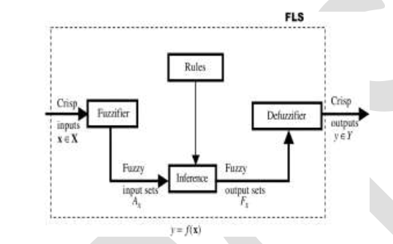

**Fig. 6.1.Fuzzy logic system.**

Its fuzzier, inference mechanism (which is associated with rules, the heart of an FLS), and output processor involve operations on fuzzy sets that are characterized by membership functions. (For more information on the FLS Uncertainty in Fuzzy Logic Systems.") An FLS that is described completely in terms of type-1 fuzzy sets is called a *type-1 FLS*, whereas an FLS that is described using at least one type-1 fuzzy set is called a *type-2 FLS*. The output processor for a type-1 FLS is a defuzzifier; it transforms a type-1 fuzzy set into a number, a type-0 fuzzy set. The output processor for a type-2 FLS has two components to it. First, type-2 fuzzy sets are transformed into type-1 fuzzy sets by means of type reduction. Then the type-reduced set is transformed into a number by means of defuzzifcation.

Type-2 FLSs, on the other hand, are very useful in circumstances in which it is difficult to determine an exact membership function for a fuzzy set; hence, they can be used to handle rule uncertainties and even measurement uncertainties.

Type-2 FLSs move the world of FLSs into a fundamentally new and important direction a type-2 FLS has more design degrees of freedom than does a type-1 FLS because its type-2 fuzzy sets are described by more parameters than are type-1 fuzzy sets. This is analogous to a probability density function being described by more parameter than its deterministic counterpart. This suggests that a type-2 FLS has the potential to outperform a type-1 FLS because of its larger number of design degrees of freedom. To date, there is no mathematical proof that this will always be the case. however, in every application to which I have applied type-2 FLSs, I have always observed that better performance is obtained using a type-2 FLS than is obtained using a type-1 FLS.

The study of type-1 fuzzy is done by referring a real life example of different age group in which we found some uncertainty issue due to which we move toward type-2.After coming to type-2,we come to know about basic of type-2 and also how to obtain type-2 using type-1 as a membership function and by mapping it to the function and after that we are going to find the minimum of all the membership function and after getting value we will find maximum of all value and the value which will come as output will be the membership value of particular value in type-2 fuzzy set

Representing type-2 fuzzy set mathematical:

$\underline{B}$ = {(y, $µ_{\underline{B}}$ (y)) | y=f ( x1, x2, x3,……….,xn) ∈ X}

$µ_{\underline{B}}$ (y) = (min [(µĀ1(x), µĀ2(x),.., µĀn(x)]),if $f^{-1}$ (y) ≠0

0 , otherwise

After finding the type-2 from the extension principle we try to find the further type of fuzzy set by using the operation such as union and intersection for which we required at least two type-2 set for performing the operations. For finding two type-2 we have divided the class in two parts one is raise and one is decrease both contain two sets of type-1 fuzzy set and its membership value is to be find by using triangular membership functions now from one part we will find one type-2 set and from other we will find other type-2 set by the use of extension principle of fuzzy logic. Now the two type-2 is generated from which we will take any random elements of type-2 and try to perform operations of type-2 fuzzy logic.

Method of operations:

Let Ā and $Ē$ are type-2 fuzzy set

Ā= {(x, µ(x))}

$\underline{E}$ = {(x, µ(x))}

Here µ(x) is not constant

$µ_{\underline{A}}$ (x) ={Ui ,µui(x) |x ∈ Χ &ui , µui∈[0,1]}

And, $µ_{\underline{E}}$ (x) ={vj,µvj(x) |x ∈ Χ &,ui, µvj∈ [0, 1]}

Intersection method:

µĀ∩Ē=µĀ∩µĒ(x) = {w,µĀ∩µĒ (w) | w = min (ui,**V**j)}

Where, µĀ∩Ē (w) =sup {min (µui , µvj)}

Union method:

µĀ∪Ē (x) =µĀ∪µĒ(x) = {w,µĀ∪µĒ (w) | w = max (ui,**V**J)}

Where, µĀ∪ Ē (w) =sup {max (µui , µvj)}

and performing union and intersection method we have analyze with the help of graph that for smaller value of x it is easy to visualize but when it come for larger value it is very difficult to analyze the set of union and intersection because of it three dimensional nature

# CHAPTER 7

# RESULT

Generating output by using extension principle rule

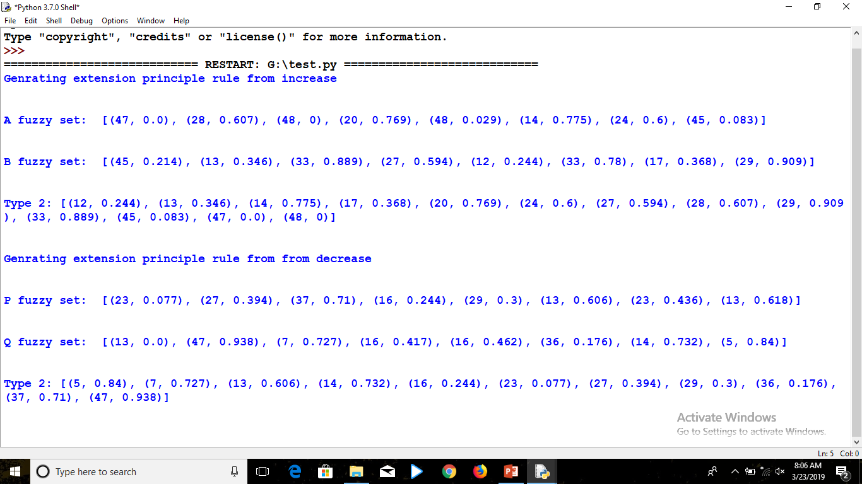

**Fig. 7.1 Result**

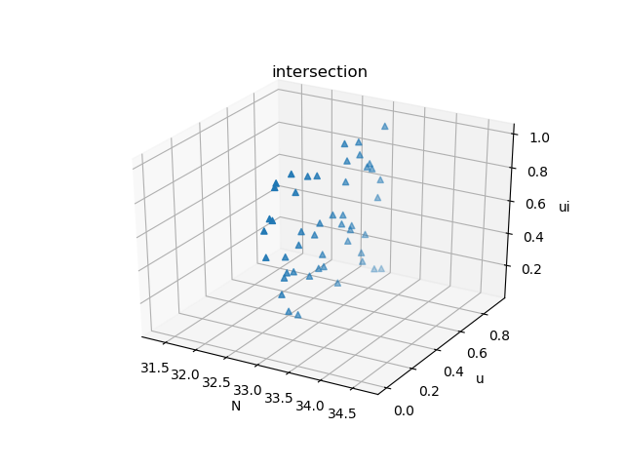

**Fig. 7.2 Output of intersection operation of type-2 fuzzy set**

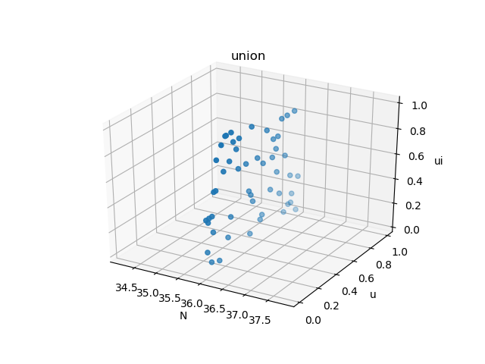

**Fig. 7.3 Output of intersection operation of type-2 fuzzy set**

# CHAPTER 8

# CONCLUSION

With the help of this project we come to know that what is fuzzy logic and what is fuzzy set, by the help of real life example we come to know how to graph is to be plotted for type-1 we found some advantage and disadvantage of type-1 and also the application of type-1 but after taking more set we found that some uncertentity occurs in type-1 and so we have decided to move for further set i.e. type-2 by referring type-1 as a membership function. At type-2 we found that it is easy to handle uncertentity in type-2 fuzzy set but it is very difficult to visualize when operation is performed. This give result that moving toward further type is difficults

# REFERENCES

1. L.A. Zadeh, Fuzzy Sets, Information, 1965
2. L.A. Zadeh,” Making computers think like people,” IEEE. Spectrum, 8/1984, pp. 26-32.
3. [L.A. Zadeh, “Outline of A New Approach to the Analysis of Complex Systems and Decision Processes”, 1973.
4. D. Zhou, J. Ma, E. Turban, N. Bolloju, “A fuzzy set approach to the evaluation ofjournal grades”, Fuzzy Sets and Systems, Volume 131, Issue 1, Pages 63-74, 1 October 2002.
5. T. Chou, & G. Liang, “Application of a fuzzy multi-criteria decision-making model for shipping company performance evaluation”, Maritime Policy & Management, 28(4), pp. 375-392, 2001
6. Ship-Peng Lo, “An adaptive-network based fuzzy inference system for prediction of work piece surface roughness in end milling”, Journal of Materials Processing Technology, Volume 142, Issue 3, pp. 665-675, 10 December 2003.
7. Met cut Research Associates Inc., Machining Data Handbook, 3rd edn, Vols I and 2. Cincinnati, 1980.
8. K. Hashmi, M.A El-Baradie, and M. Ryan, “Fuzzy-logic based intelligent selection of machining parameters”, Journal of Materials Processing Technology, Vol. 94, Issues 2–3, pp 94–111, September 1999.
9. M. Balazinski, M. Bellerose, E. Czogala, “Application of fuzzy logic techniques to the selection of cutting parameters in machiningprocesses”, Fuzzy Sets and Systems, Volume 63, Issue 3, pp. 307-317, 10 May 1994.
10. Pappis, C., Mamdani, E., (1977) “A fuzzy controller for atraffic junction”, IEEE Transactions on Systems, Man and Cybernetics SMC-7, pp. 707-717
11. Abbasi, M.M., Kashiyarndi, S., 2006. Clinical decision support systems: a discussion on different methodologies used in health care (2006)